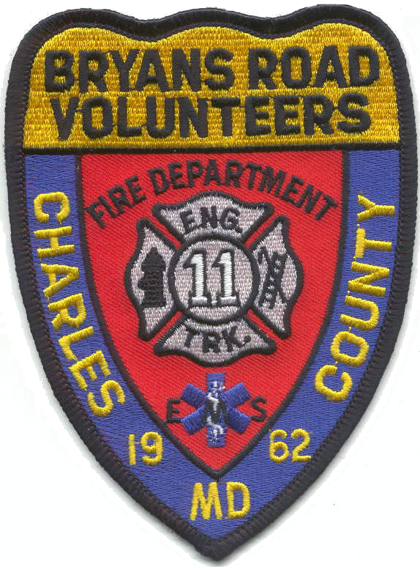
Bryans Road
Volunteer Fire Dept. & Rescue Squad, Inc.

P. O. Box 111, BRYANS ROAD, MARYLAND 20616

It is with great sadness and a heavy heart that the Bryans Road Volunteer Fire Department and Rescue Squad Inc., announces the passing of Charter Member Robert G. (Bob) Eastburn. Bob passed away on Friday, 12 May 2023 at 97 years of age.

Bob was instrumental in the organization of the Bryans Road Volunteer Fire Department and served as Secretary of the department for many years. Bob had 69 years of service to the citizens of Charles County. Prior to the organization of Bryans Road VFD, Bob was a member of the Indian Head Volunteer Fire Department where he served as an Assistant Chief and President. Bob is also a Past-President of the Charles County Volunteer Firemen’s Association (1962)

We are grateful for his dedicated service to our department and surrounding communities.

Arrangements are as follows:

Visitation at Station 11:
Bryans Road Fire Department and Rescue Squad
3099 Livingston Road, Bryans Road, MD 20616

Thursday, 18 May 2023
1700 to 2000
Fireman’s Prayer @ 1900

Funeral
Bryans Road Fire Department and Rescue Squad
Friday, 19 May 2023
1000
Procession leaving BRVFD

Interment
Trinity Memorial Gardens
3221 Mattawoman Beantown Rd
Waldorf, MD 20601
Friday, 19 May 2023
1100

In lieu of flowers, memorial donations can be sent in his name to:
Bryans Road VFD & Rescue Squad Inc.
PO Box 111, Bryans Road MD, 20616

Departments wishing to bring apparatus or assist with traffic control, please contact Assistant Chief Tony Delozier @ 301-399-5015

